Different types of markets – Retail Markets
As we have seen, a market exists in any situation where buyers and sellers come together to exchange goods and services for money. A market can exist in a physical location, it can be spread across a number of locations, or can have no physical location at all, when buying and selling happens in cyberspace. It is the act of buying and selling, not the actual location, that creates the market. We will now look at a number of different markets that exist within the Australian economy: retail markets, labour markets, financial markets, and stock markets.

Retail markets
We are all very familiar with retail markets. These are the markets that allow us to buy most of our goods and services. They include:
- the shopping areas in the central business districts (CBDs) of our large capital cities
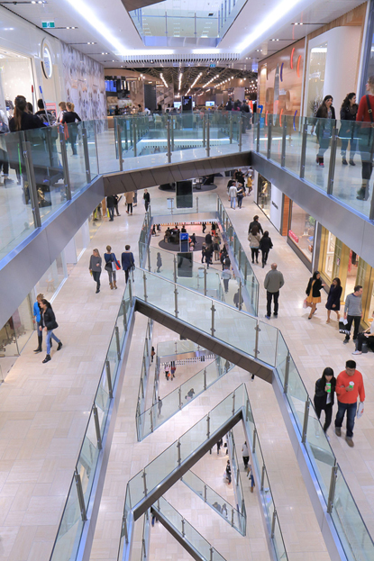
- the huge suburban shopping malls such as Chadstone in Melbourne, or Westfield centres at Parramatta in western Sydney and Chermside in northern Brisbane
- local shopping centres with a supermarket and a number of specialty stores
- shopping strips located along major roads and near public transport hubs
- the groups of shops gathered in the main streets of country towns and regional centres
- online shopping websites.

The last fifteen years has seen a huge increase in online shopping. In 2014, online shopping in Australia was worth more than $15 billion, an amount equivalent to 6.6 per cent of all retail sales. Almost 75 per cent of this online shopping involved purchases from Australian retailers, and therefore around one-quarter of all online shopping in Australia saw goods imported directly from overseas businesses. Online shopping is likely to continue to grow, and the proportion of goods being bought from overseas businesses is likely to become larger as more people become aware of the wide range of choices available around the world.
Figure 1 Large shopping malls provide a wide range of retail businesses.

Answer the questions based on the reading:
- Define a ‘retail market’
_______________________________________________________________________________________________________________________________________________________________________________________________________________________________________________________________
- List 5 different examples of retail markets that you know of (be specific with locations and details).
_______________________________________________________________________________________________________________________________________________________________________________________________________________________________________________________________
- Complete this sentence … “In 2014, online shopping in Australia…”

_______________________________________________________________________________________________________________________________________________________________________________________________________________________________________________________________

- Describe in your own words why you think online shopping is likely to continue to grow.

____________________________________________________________________________________________________________________________________________________________________________________________________________________________________________________________________________________________________________________________________________________

